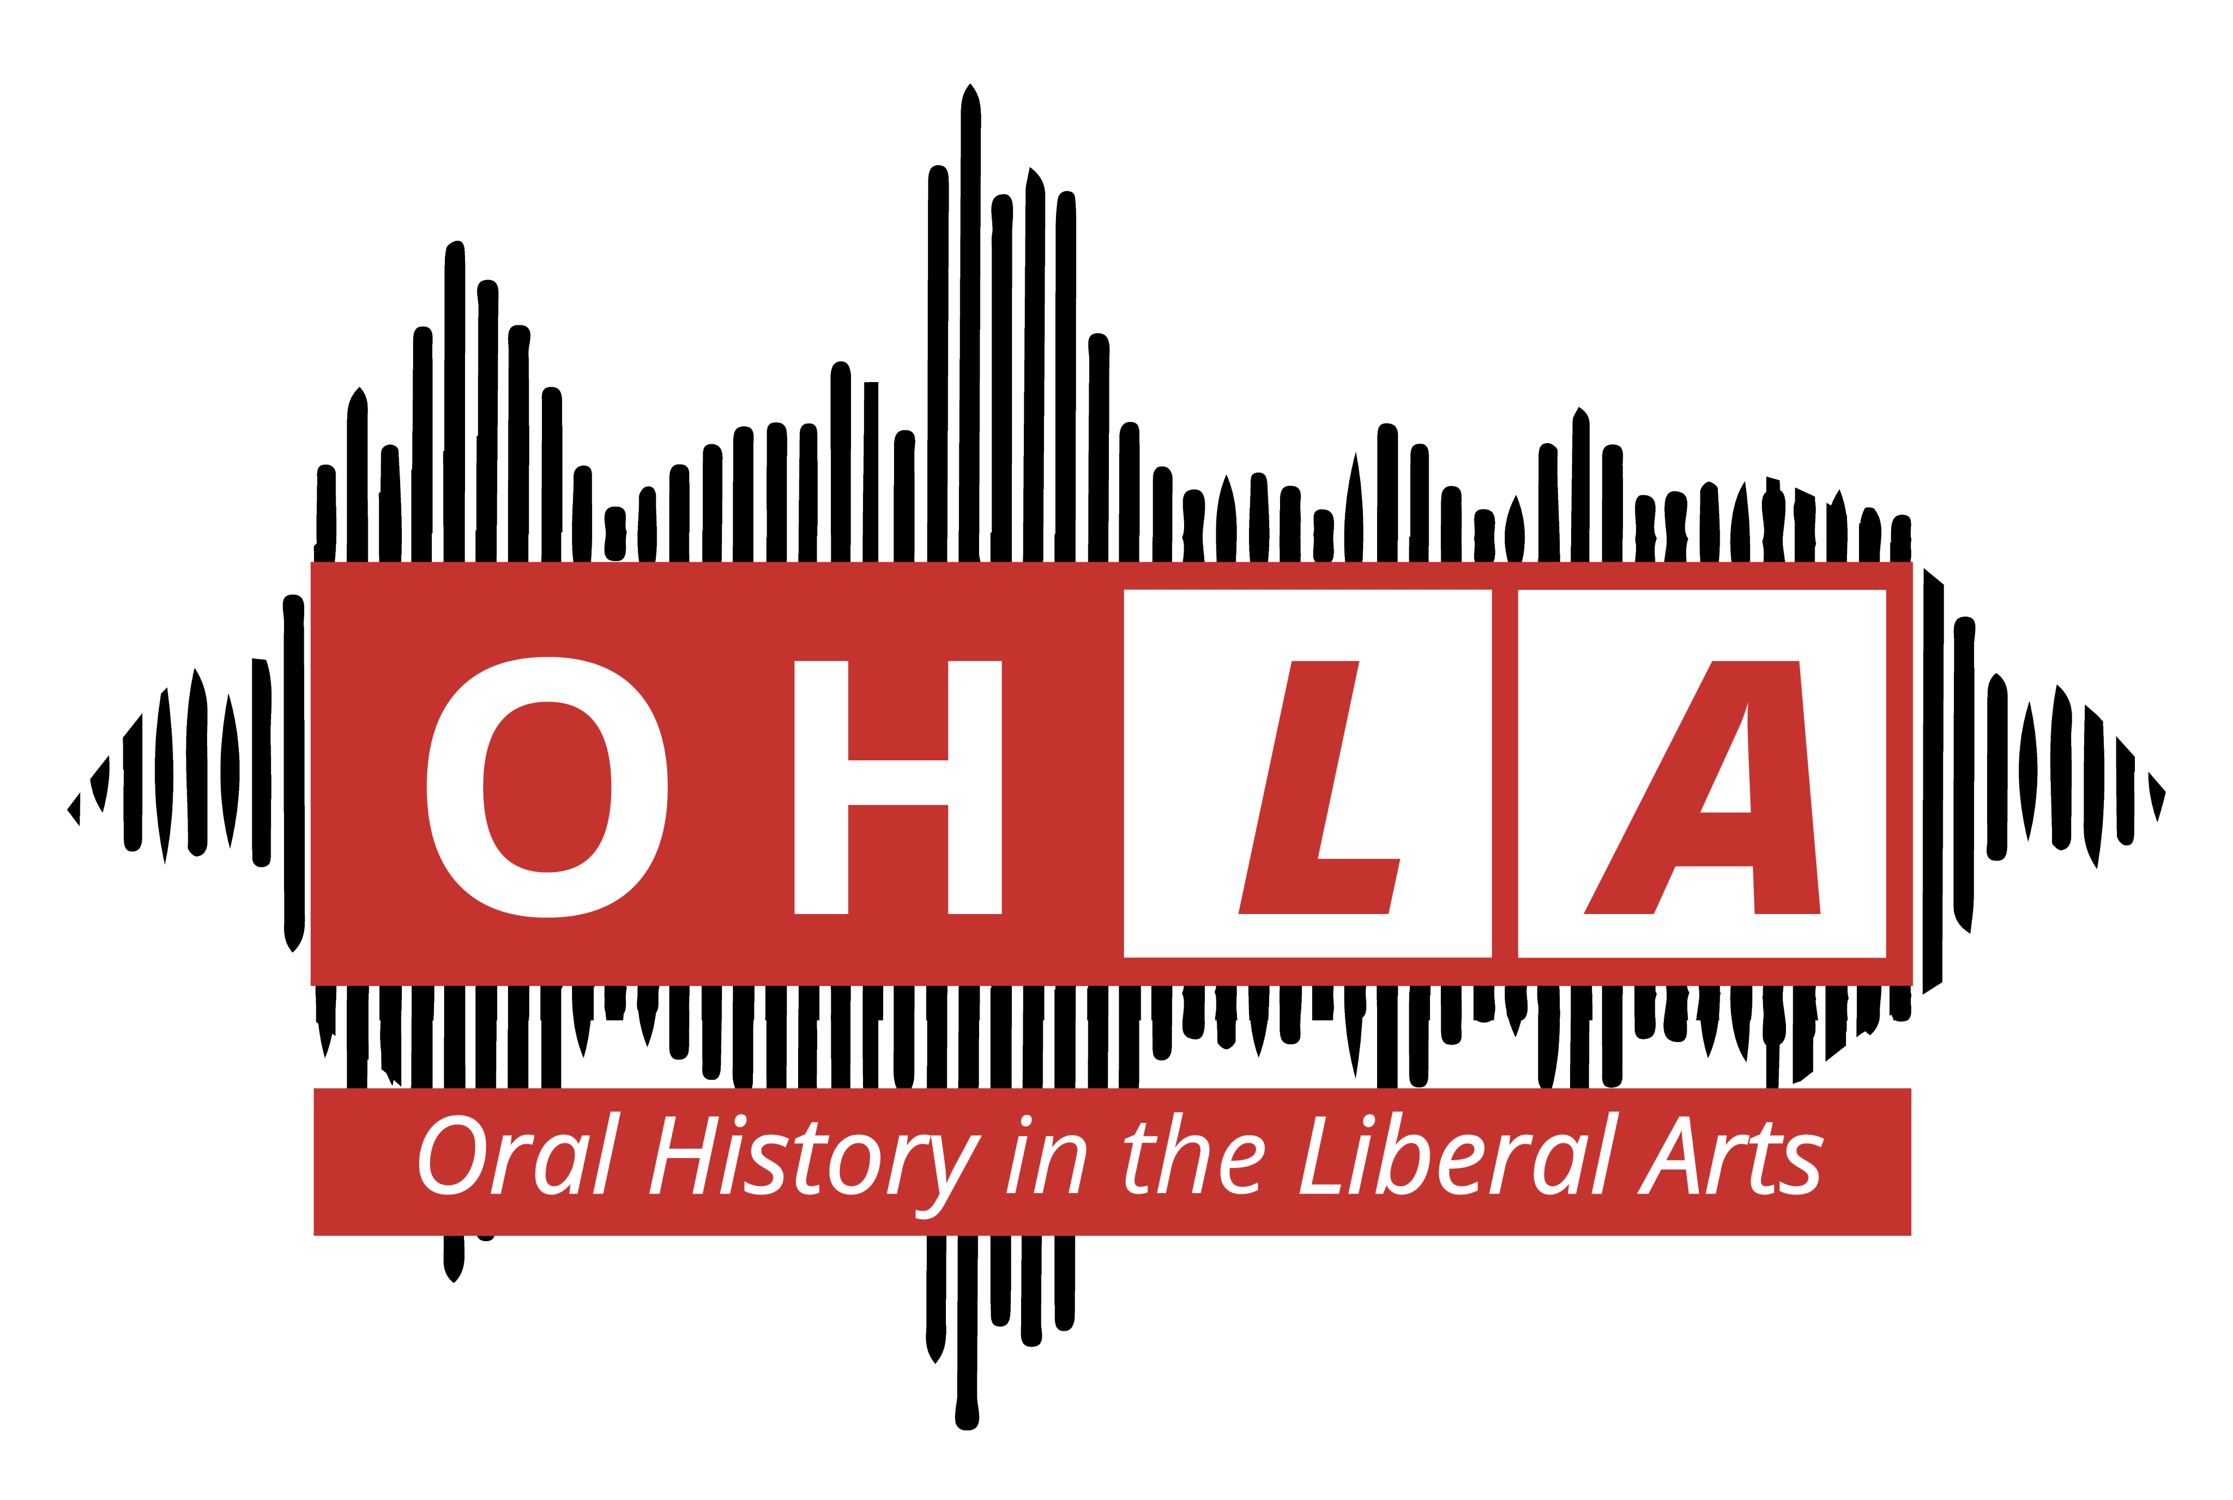

Interview Project Release Form
Oral History in the Liberal Arts Undergraduate Research
Antioch College student is conducting an interview project focused on .
This effort is intended to deepen student learning. The full interview, or excerpts from it, may be published, incorporated in original writing, or produced into audio/visual productions for educational purposes. This may include public presentations, online digital projects with a broad public audience, and creative works such as essays or written accounts. By my signature below, I (we) consent to participate in an audio or video recorded interview and allow the use of the recorded audio/video materials (or transcriptions thereof) in productions for any educational purposes in perpetuity without further consideration from me.

The interview, recorded on , is an unrestricted gift to student

. I (we) hereby intend to transfer legal title and all intellectual property rights which I (we) possess in such interview or recording, including copyright. I understand that photographs, video, audio footage, and testimonials resulting from this recorded interview may be incorporated into public works, broadcast at public events, and/or become accessible online and in blog posts. I consent to any future archive arrangements for this interview and its associated media and materials.

SIGNATURE OF INTERVIEWEE SIGNATURE OF INTERVIEWER

PRINTED NAME PRINTED NAME

STREET CITY, STATE, ZIP STREET CITY, STATE, ZIP

DATE DATE

